HOTEL

INTRODUCTION TO MOBILE PROGRAMMING

MAD_307 (TEAM-2)

Prepared to: Prepared by:

REZA MADABADI Content and Documentation along with UML:

RAM BABU JONUBOYENA (1893718)

Design:

SANDEEP REDDY DONTIREDDY (1892897)

Prototype:

VINOD KUMAR KASTALA (1893125)

Wire Frame:

BHARATH VAMSHI YAMALA (1893763)

**Table of Contents**

1.0 INTRODUCTION...............................................................................................4

1. PURPOSE............................................................................................................4

3.0 SCOPE….............................................................................................................4

4.0 ADVANTAGES..................................................................................................4

5.0 REQUIREMENT ANALYSIS…........................................................................4

5.1 Functional Requirements...........................................................................4

5.2 Non-Functional Requirements..................................................................5

6.0 UML DIAGRAMS..............................................................................................5

6.1 Use Case Diagram. ...................................................................................5

6.2 Sequence Diagram.....................................................................................7

7.0 DESIGN...............................................................................................................8

7.1 Home Page................................................................................................8

7.2 Sign in (user).............................................................................................9

7.3 Search Hotels by category.......................................................................10

7.4 Hotels Description...................................................................................11

7.5 Payment...................................................................................................12

7.6 Payment Details.......................................................................................13

7.7 Booking Confirmation.............................................................................14

7.8 Menu Bar.................................................................................................15

7.9 Profile......................................................................................................16

7.10 Help.......................................................................................................17

7.11 Customer Service..................................................................................18

7.12 Location................................................................................................19

7.13 Search....................................................................................................20

8.0 TESTING PLAN ..............................................................................................21

8.1 Test Case 1..............................................................................................21

8.2 Test Case 2..............................................................................................21

8.3 Test Case 3 .............................................................................................21

8.4 Test Case 4..............................................................................................21

8.5 Test Case 5..............................................................................................22

8.6 Test Case 6…..........................................................................................22

9.0 IMPLEMENTATION.......................................................................................22

9.1 Software Requirement.............................................................................22

9.2 Hardware Requirement............................................................................22

10.0 CONCLUSION...............................................................................................22

11.0 REFERENCES................................................................................................23

11.1 Bibliography..........................................................................................23

1. Introduction:

* We are going to design a mobile Application that books hotel on season basis.
* Filtering our application based on seasons so that user can book a desired hotel easily.

2.0. Purpose:

* To minimize the customer confusion about the hotel booking in particular seasonal mood.
* In our application the user can choose the hotel depends on the particular season which is user friendly.

3.0. Scope:

* We will make the application as simple as possible which doesn’t look like gibberish.
* We will make regular updates for the application with more features and also consider user’s feedbacks for updates.

4.0. Advantages:

* Application was created which meets the perspectives of users.
* Application is user friendly.

5.0. Requirement Analysis:

5.1. Functional Requirements:

* The system supports users booking and able to modify them.
* Users can search hotels based on the seasons (summer, winter, spring).
* Users able to cancel their booking from their account.
* Users can make online payment with credit or debit card, PayPal and Apple pay.
* Admin must send booking confirmation email after successful payment.
* Users can write reviews about hotels also rate them.
* Users can send feedback for booking purposes.
* Users can check for latest coupon codes.

5.2. Non-Functional Requirements:

* The system must ensure that all the transferable data as for examples users credit or debit card number, CVV code,

E-payment should be done in secured connection.

* The system must be able to handle multiple transactions a time.
* The system must provide customers 24*7 hours online booking service.
* The system should support almost all the browsers (Internet Explorer, Safari, Chrome, and Firefox).

6.0. UML Diagrams:

6.1. Use Case Diagram:

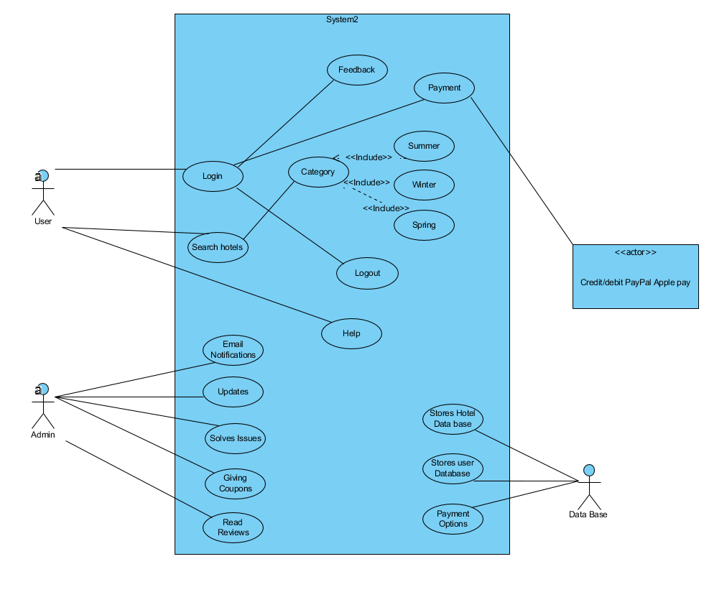

6.2. Sequence Diagram:

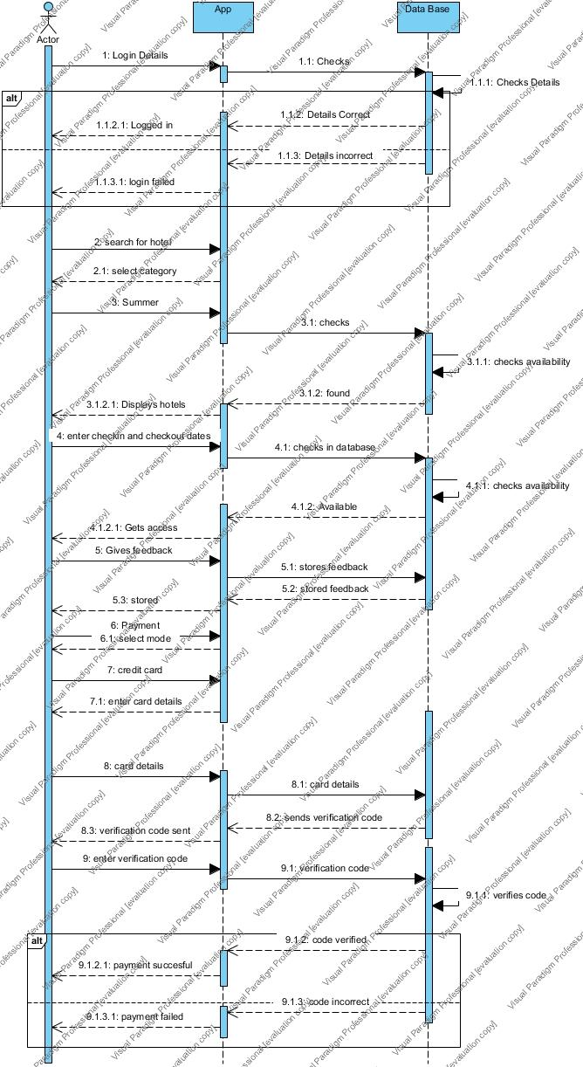

7.0. Design:

7.1. Sign in:

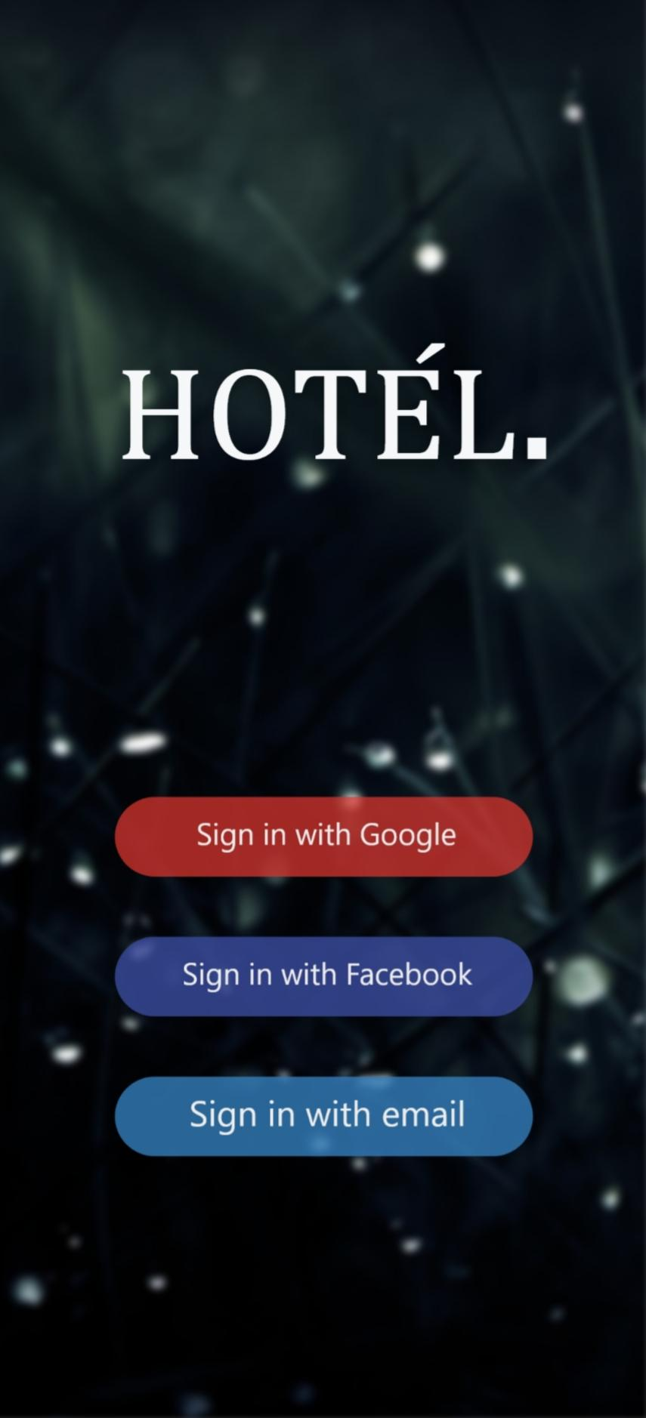

7.2. Home Screen:

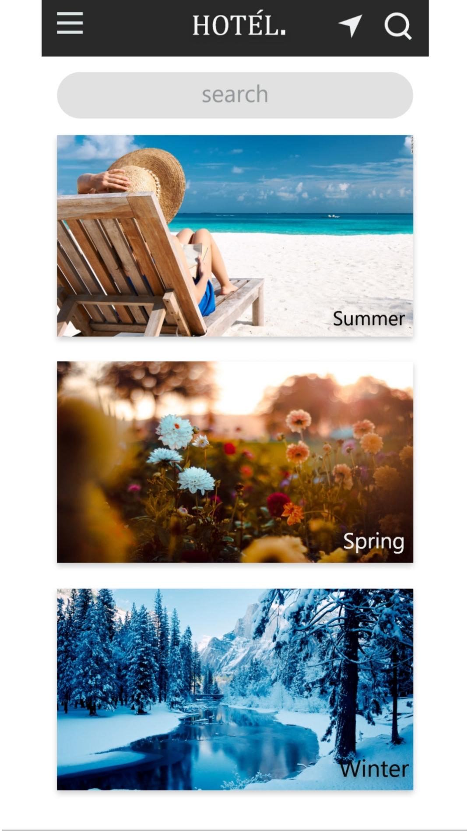

7.3 Search Hotel by Category:

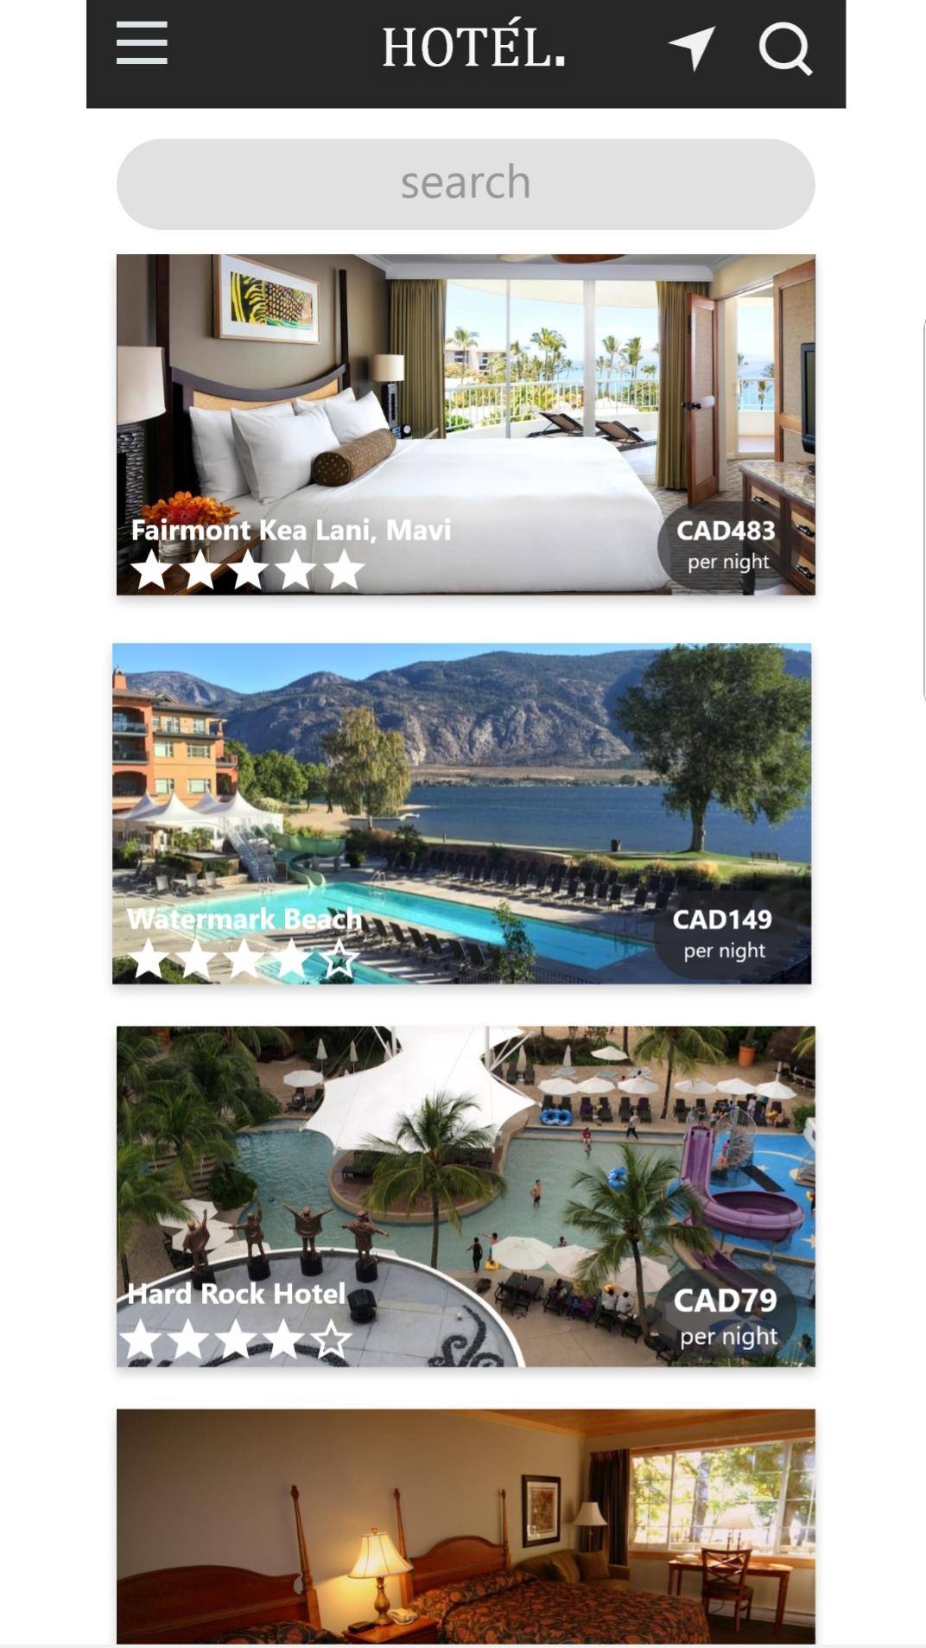

7.4 Hotel Description:

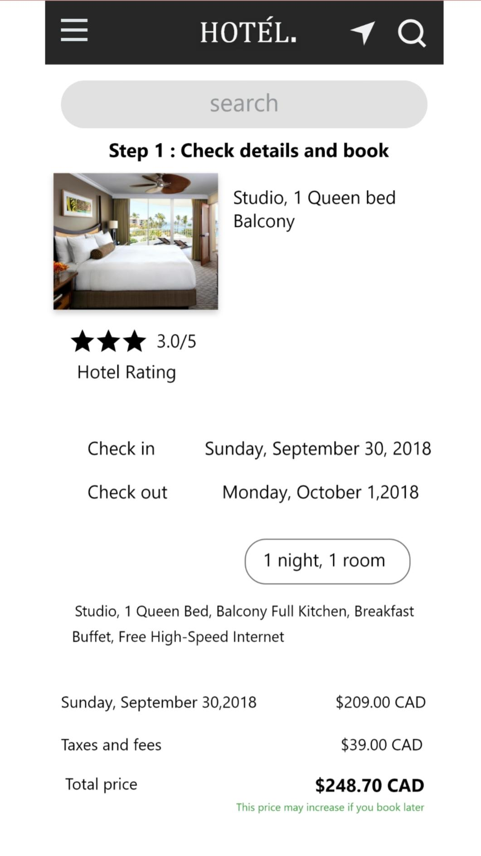

7.5. Payment Type:

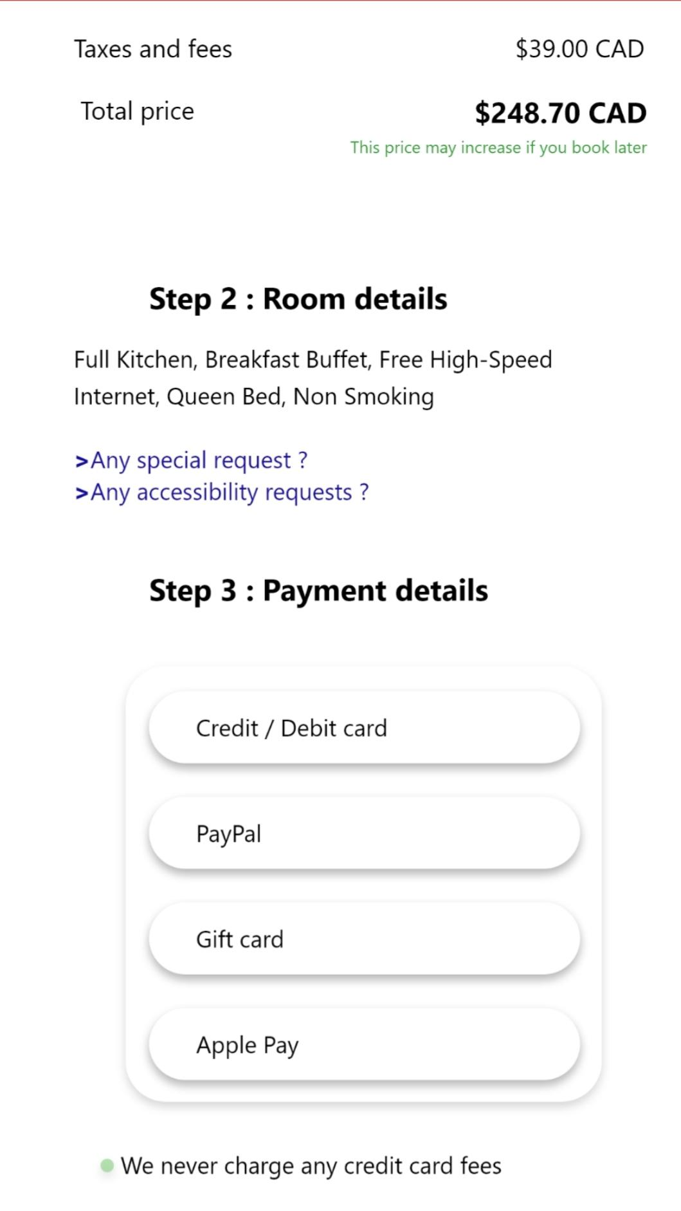

7.6. Payment Details:

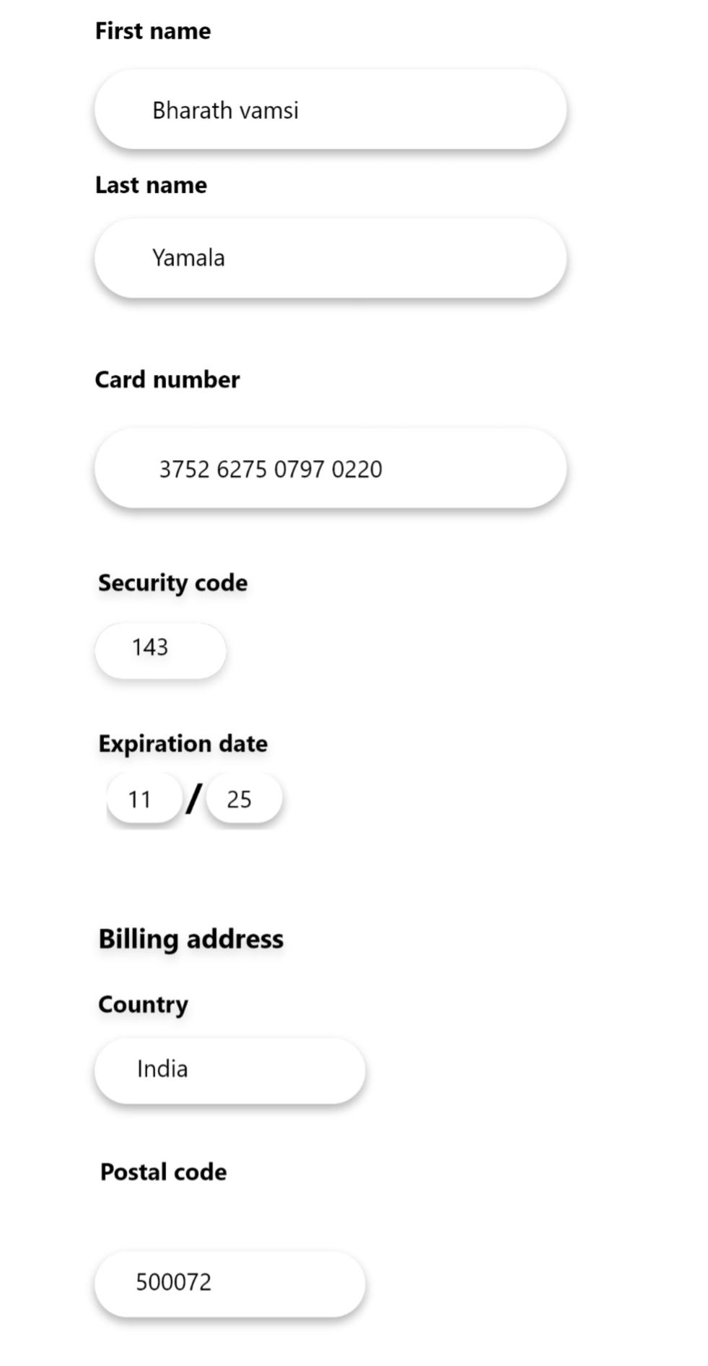

7.7. Booking Successful:

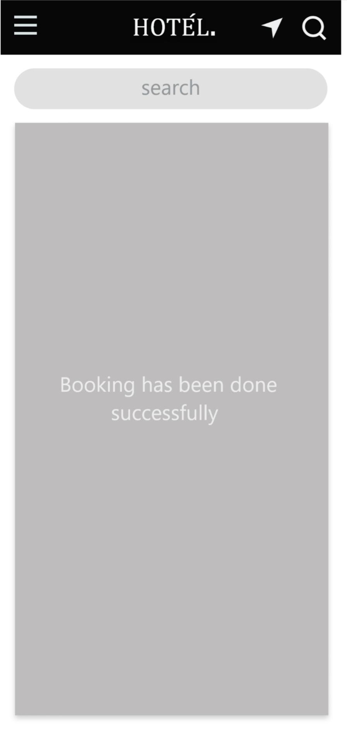

7.8. Menu Bar:

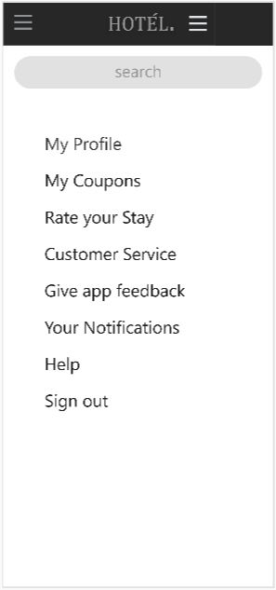

7.9. Profile:

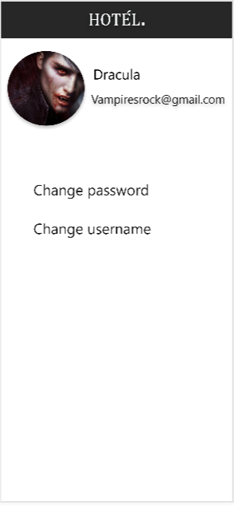

7.10. Help:

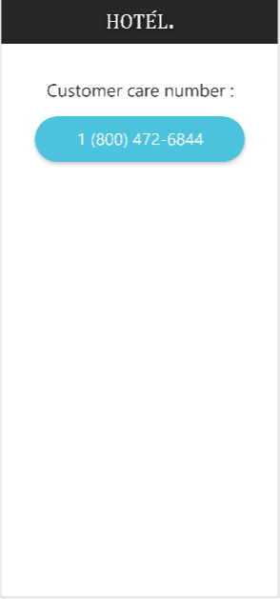

7.11. Customer Service:

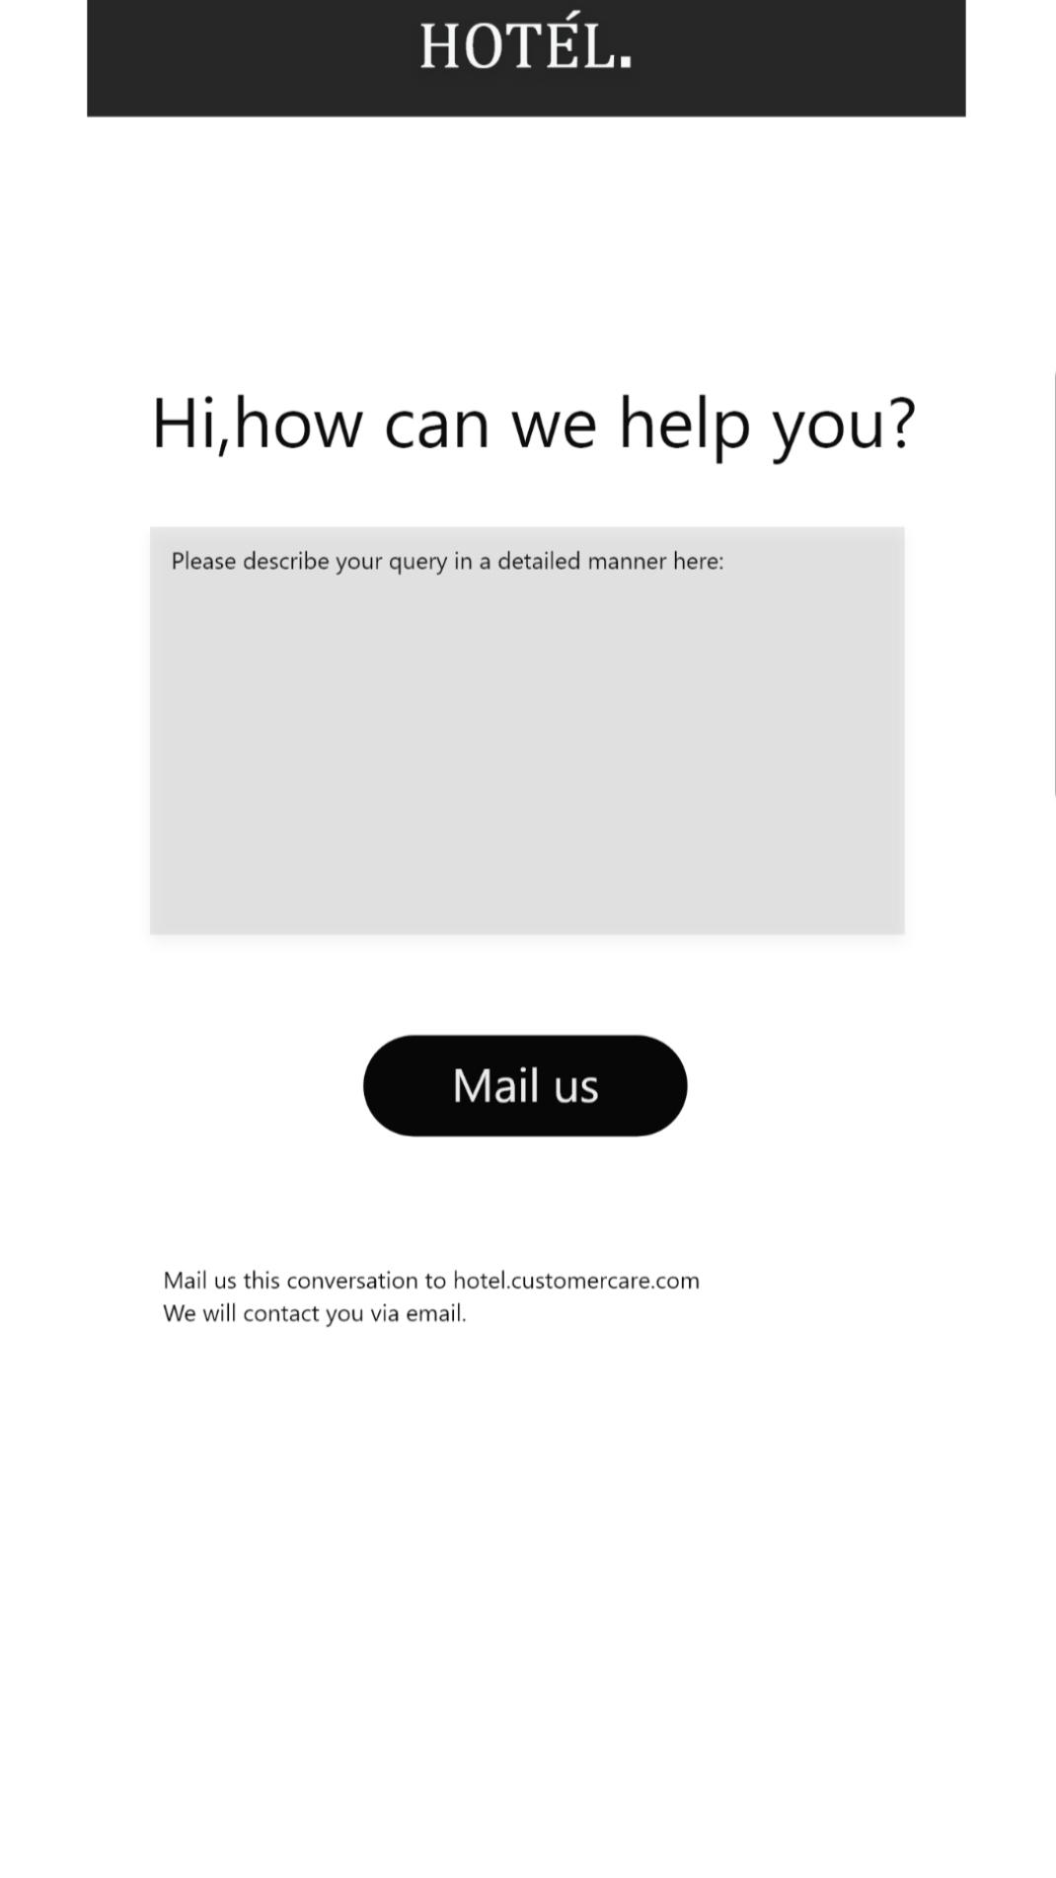

7.12. Location:

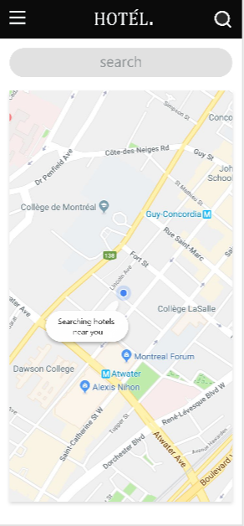

7.13. Search:

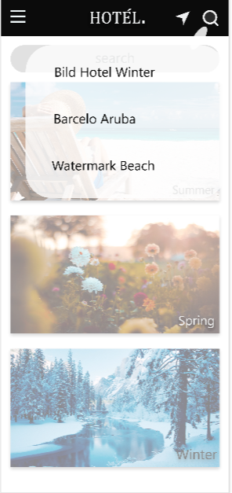

8.0 Testing Plan:

8.1. Test Case 1:

* Test Title: User Login.
* Test Procedures: Google Account, Facebook, email.
* Test Data: Entered Google, Facebook, email details must be valid.
* Expected Result: It will redirect to login page.

8.2. Test Case 2:

* Test Title: Hotel Icon
* Test Procedures: Click on the icon.
* Test Data: Users need to click on the icon bar.
* Expected Result: It will redirect to the system home page.

8.3. Test case 3:

* Test Title: Location
* Test Procedures: User can know the current location which is used to see the nearby hotels
* Test Data: Click on the location icon and verify whether location current location or not
* Expected Result: It will show the current location.

8.4. Test Case 4:

* Test Title: Search.
* Test Procedures: Type destinations name with selecting check-in and check-out.
* Test Data: Valid destinations name with date.
* Expected Result: System will search according to User’s choice.

8.5. Test Case 5:

* Test Title: View Booking Button
* Test Procedures: Users need to sign in and can book hotel when they press book now button.
* Test Data: Book their particular hotel from the list.
* Expected Result: Will book the hotel and stores in the database.

8.6. Test Case 6:

* Test Title: Payment
* Test Procedures: Users need to enter the type of the payment and valid details
* Test Data: Card details, Pay Pal details and validate the One-time password
* Expected Result: Payment successful if the details are valid.

9.0. Implementation:

9.1. Software Requirements:

* **Operating System**: Windows 10
* **Web Browser**: Google Chrome, Internet Explorer, Mozilla Firefox
* **Web Development System**: Git Hub, Adobe XD,

Adobe toolkit, Visual Paradigm, Word Document, PowerPoint.

9.2. Hardware Requirements:

* **RAM**: 8GB
* **HDD**: 128 SSD
* **Processor**: Intel i5 (8th Gen).

10.0. Conclusion:

This application was created keeping in mind of other trending applications on market which lacks proper design which makes confusion to the user. Our application meets the needs of the users.

11.0. References: Dansky you tube tutorials

11.1. Bibliography:

<https://www.behance.net/gallery/55462459/Wires-wireframe-kits-for-Adobe-XD>

<https://developer.apple.com/design/resources/>

<https://docs.microsoft.com/en-us/windows/uwp/design/downloads/>